***War Simulation of Fighter Planes***

***Team: Chiranjeevi Ramamurthy***

***Vaishak Ramesh Vellore***

***Ananya Dutta***

**Description:**

The idea is to provide a vivid flying experience for actual gaming which involves movement of the fighter jet in the given Virtual world. The game has the following settings,

* The Fighter Plane is flying along the river surrounded by mountains enclosed in a skybox.
* Reflections and Shadows due to the light direction which can be toggled on and off.
* The virtual world has fog setting which can switched be on and off.
* A multi-scale terrain which in turn can be turned on and off based on requirement.
* The noise textures can be removed and added on.
* A bounding box enclosing the fighter jet and the terrain separately which can be used for collision detection.
* Skybox can be drawn or removed.

Below are the attached screenshots of how the game might look like in the future versions. Added the screenshots to get a clear idea of what the final experience could be.

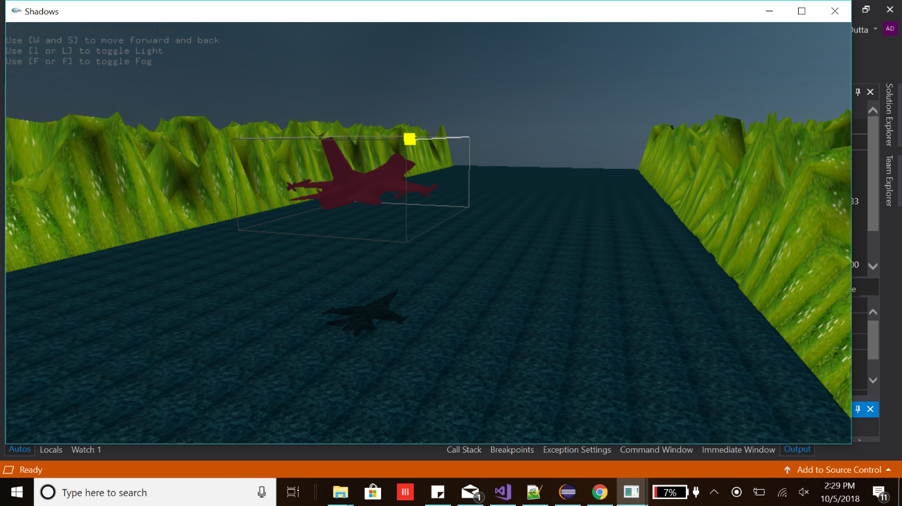

Sample screenshot of the game with fog turned off and light turned on

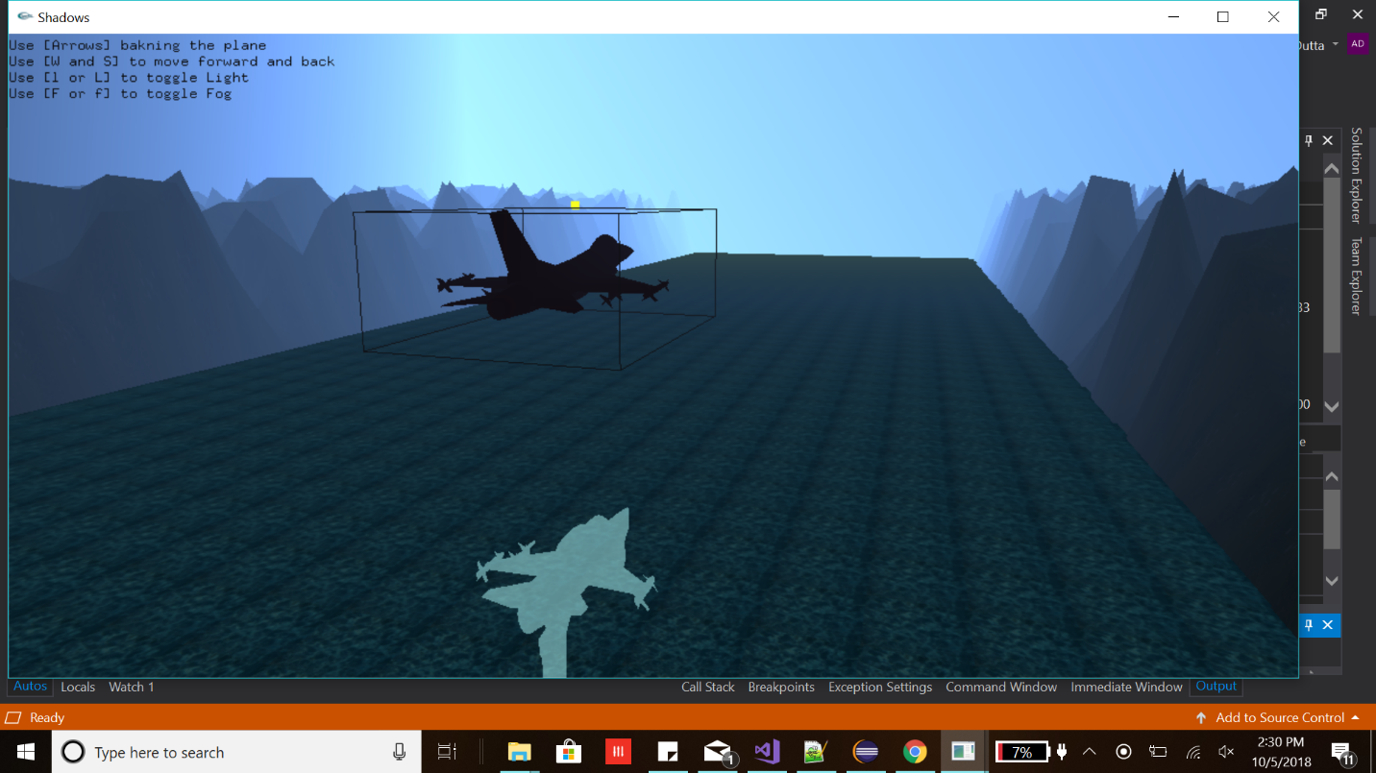

Sample screenshot of the game with light turned off and fog turned on.

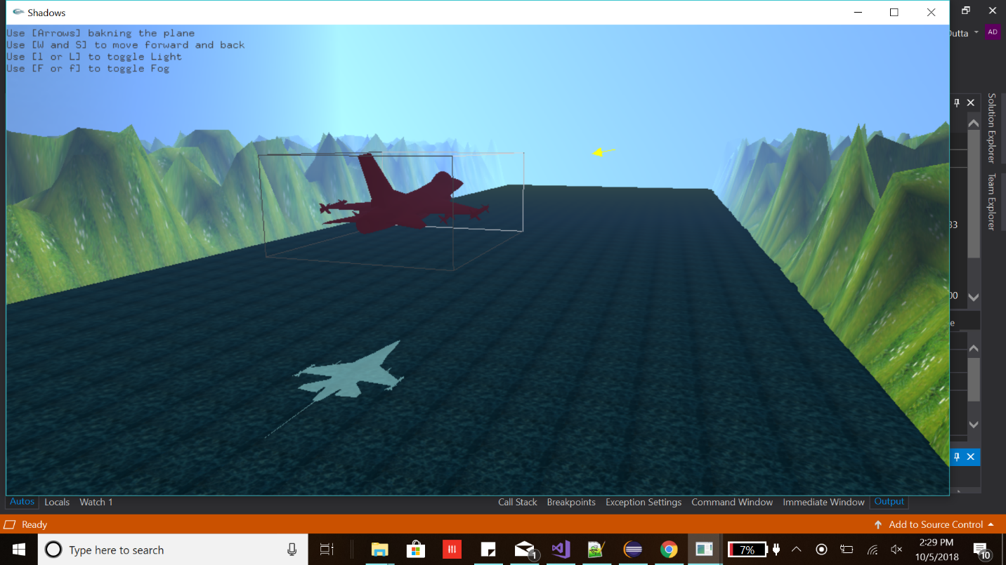

Sample screenshot of the image with fog and light turned on.

**Note:** The submitted code contains all the required features which were asked for the initial version of the game.